CLUNES PUBLIC SCHOOL

RESPECT | RESPONSIBILITY | INTEGRITY

Walker Street Telephone 6629 1278

Clunes 2480 Fax 6629 1040
Email; clunes-p.school@det.nsw.edu.au
Principal: Michelle Slee

Kim Michelle Toft Presentation
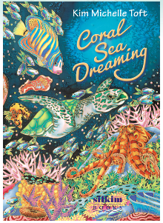
Tuesday 21st July

Dear Parents and Carers

On Tuesday 21 July, Kim Michelle Toft, a local author and illustrator, will be visiting the school for a 1 hour whole school presentation based around her wonderful books and her silk paintings. After this presentation, Kim will be holding a special Year 6 only art workshop, where students produce their own individual painting which they get to keep.

Cost for the presentation is $5 per child or $10 per family.
There is an additional cost of $5 for the Year 6 art workshop.

We have booked 12 places for the art workshop and we need Year 6 students to confirm if they will be attending the art workshop as any spare places will be offered to Year 5 students.

We will need numbers prior to the holidays to confirm our booking so please complete the attached permission slip and return to school by this Friday 3 July. Payment can be made by EFTPOS at the office or online via the school website Make a Payment link or the Skoolbag NSW Westpac Payment Gateway.

If you would like to purchase any of Kim’s books please contact the office to order.
Soft covers $18; hard cover $25. To see a list of her books go to https://www.kimtoft.com.au/book-store

Michelle Slee
PRINCIPAL
…………………………………………………………………………………………………………………………………….……
Permission Note – Kim Michelle Toft Presentation and Workshop

I hereby give permission for my child / children ___________________________________________

to participate in the Kim Toft Presentation on Tuesday 21st July at a cost of $5/ student or $10/family.

I have a child in Year 6 who WILL / WILL NOT (please circle your choice) be attending the art workshop at a cost of $5 in addition to the presentation cost.

I have enclosed payment of $...................

I have paid online the amount of $................ and my receipt number is _______________________

Signed: _______________________________________ Date: _________________
(Parent/Carer)

