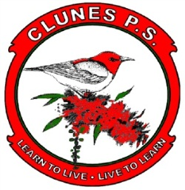

CLUNES PUBLIC SCHOOL

Walker Street Telephone: 6629 1278

Clunes 2480 Fax: 6629 1040
Email: clunes-p.school@det.nsw.edu.au
Principal: Michelle Slee

Clunes, Goolmangar and Rosebank Public Schools 4/5/6 Overnight Brisbane Excursion 2021
Thursday 16th September to Friday 17th September 2021
26th April 2021
Dear Parents and Carers,
Our students will be participating in an overnight excursion to Brisbane accompanied by Mrs Slee - Clunes PS Teacher, Parent - Mr Mitchell, Mrs Bertuzzi from Goolmangar PS and Mrs Thomson from Rosebank PS.
We will leave Clunes at 6:30am and travel by coach to Beenleigh Historical Village and in the afternoon we will be visiting Lone Pine Koala Sanctuary. We will stay overnight at the Brisbane City YHA.
On the Friday we will travel onboard the St Helena Cruise to St Helena Island where we will participate in an educational program about the island.
All meals will be provided and further details regarding this will be provided closer to the excursion.
We will return to Clunes Public School on Friday at 6pm.
The cost of this excursion is $260 (unless student numbers decrease). Parents are asked to pay a deposit of $50 by 7th May.
Our intention is to ensure no children miss out on any programs due to financial reasons. Please contact the Principal confidentially or speak with office staff to find out more regarding financial assistance.
Michelle Slee
Clunes PS Principal
-----------------------------------------------------------------------------------------------------------------------------
Year 4, 5 & 6 Overnight Excursion to Brisbane

I hereby give permission for my child/ children ……………………………………………………………………….to attend the 2021 Y4, 5, 6 Overnight Excursion to Brisbane.
I have paid $50.00 deposit for the excursion

I have paid for the excursion in full - $260.00

Signed …………………………………………………………………………………………. Date ………………………………………….
Parent /Carer

Please return to school by Friday 7th May

